Jill Wright 5/10/2021

Disaster Income Loss – Relief Package Roll Out factors.

Geospatial -Spring 2021

Jill Wright

**Purpose of the Research**: The purpose of the research was to familiarize the

researcher with the use of census datasets, and also find other correlating sources.

of data that look at economic factors and United States demographics. The main

purpose is to show the correlations that can be shown by analyzing key factors in

our country to for proactive disaster relief, and equity in rolling out government plans.

in devastating country events, such as during the time of COVID-19 pandemic.

**Background and Rationale:** My inquiry question-What factors can be used to

roll out disaster relief. The research attempts to look at who really needs help the quickest.

Who will be in danger if aid is not given in a pandemic?

**Key Data sources were**:

Urban Institute Dataset-Job Loss by Tract – dataset projected 2020 Covid job loss using 2018 census data.

United State Shapefile for California by tract -2018

United State Census Data Table 1101 -2018 -contains demographics on families by tract.

**Analysis Steps:**

|  |  |  |
| --- | --- | --- |
| Research Datasets |  |  |
| Download 2018 Tiger line Shape | Shape of California |  |
| Downloaded Census Table 1101 | Household demographic 2020 |  |
| Download Urban Institute Dataset | Income loss by tract | Based on 2018 census data projected into Covid 2020 |
| Removed the Job_Loss_by_tract.csv bad data | Space and nulls from Urban Institute dataset using search and replace |  |
| Census 1101 | Changed column headings |  |
| Imported data in | qgis |  |
| Created Shape layer |  |  |
| Imported the jobs loss dataset as csv | Joined to shape layer of CA tracts | Joined on geo-id which had to formatted to 11 character on job loss dataset |
|  | Add Gradient of tracts by Job loss |  |
| Import Census 1101 table csv | Joined to tract shapefile |  |
| Added the household size data  Did Count points in the polygon but did not use | To shape tracts | Joined on geocode and geo on census file had to be changes to 11 character to match shapefile |
| Took Pictures on QGIS with snippet | With various numeric data for household sizes |  |
| Created Research Paper and File |  |  |
| Uploaded to folder |  |  |
|  |  |  |
|  |  |  |
|  |  |  |
|  |  |  |
|  |  |  |
|  |  |  |
|  |  |  |
|  |  |  |

Analysis Information:

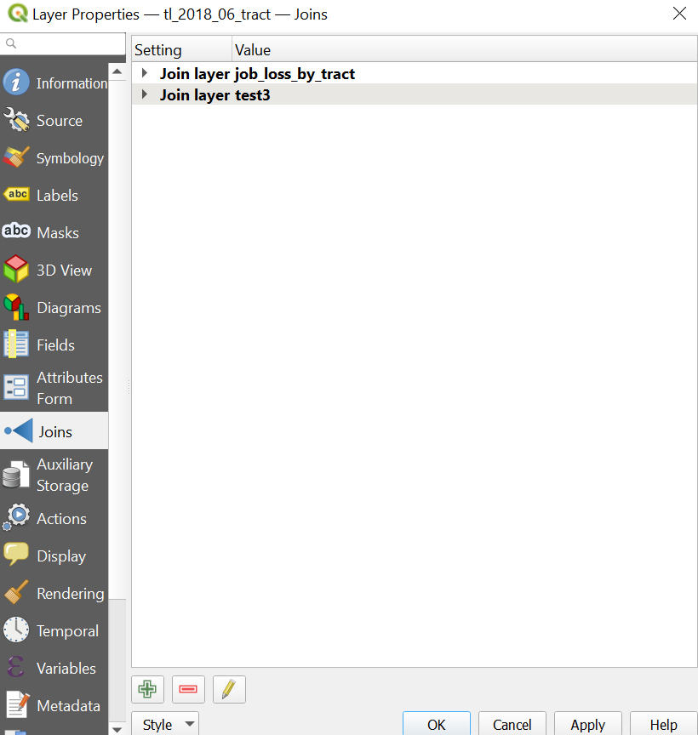

**Layer information**

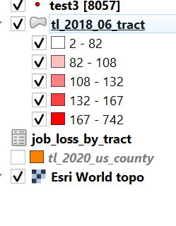

**Attribute table information of tract layer:**

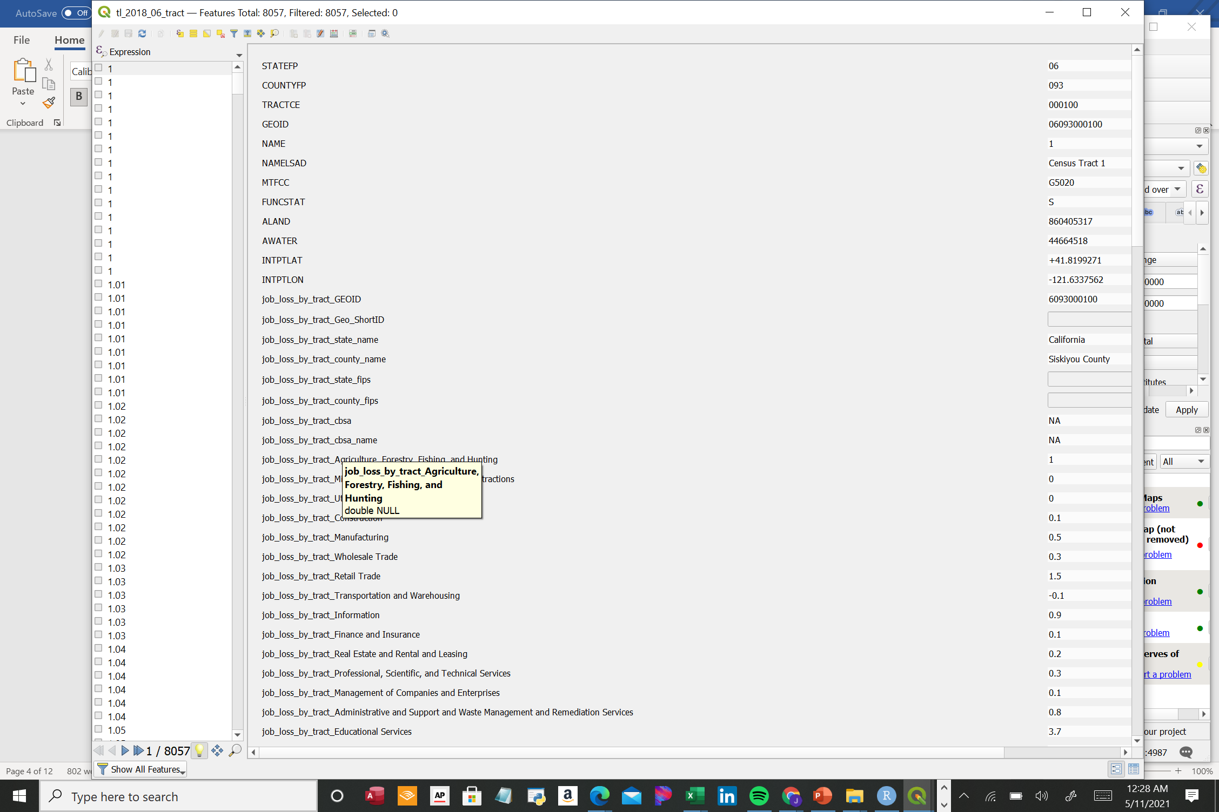

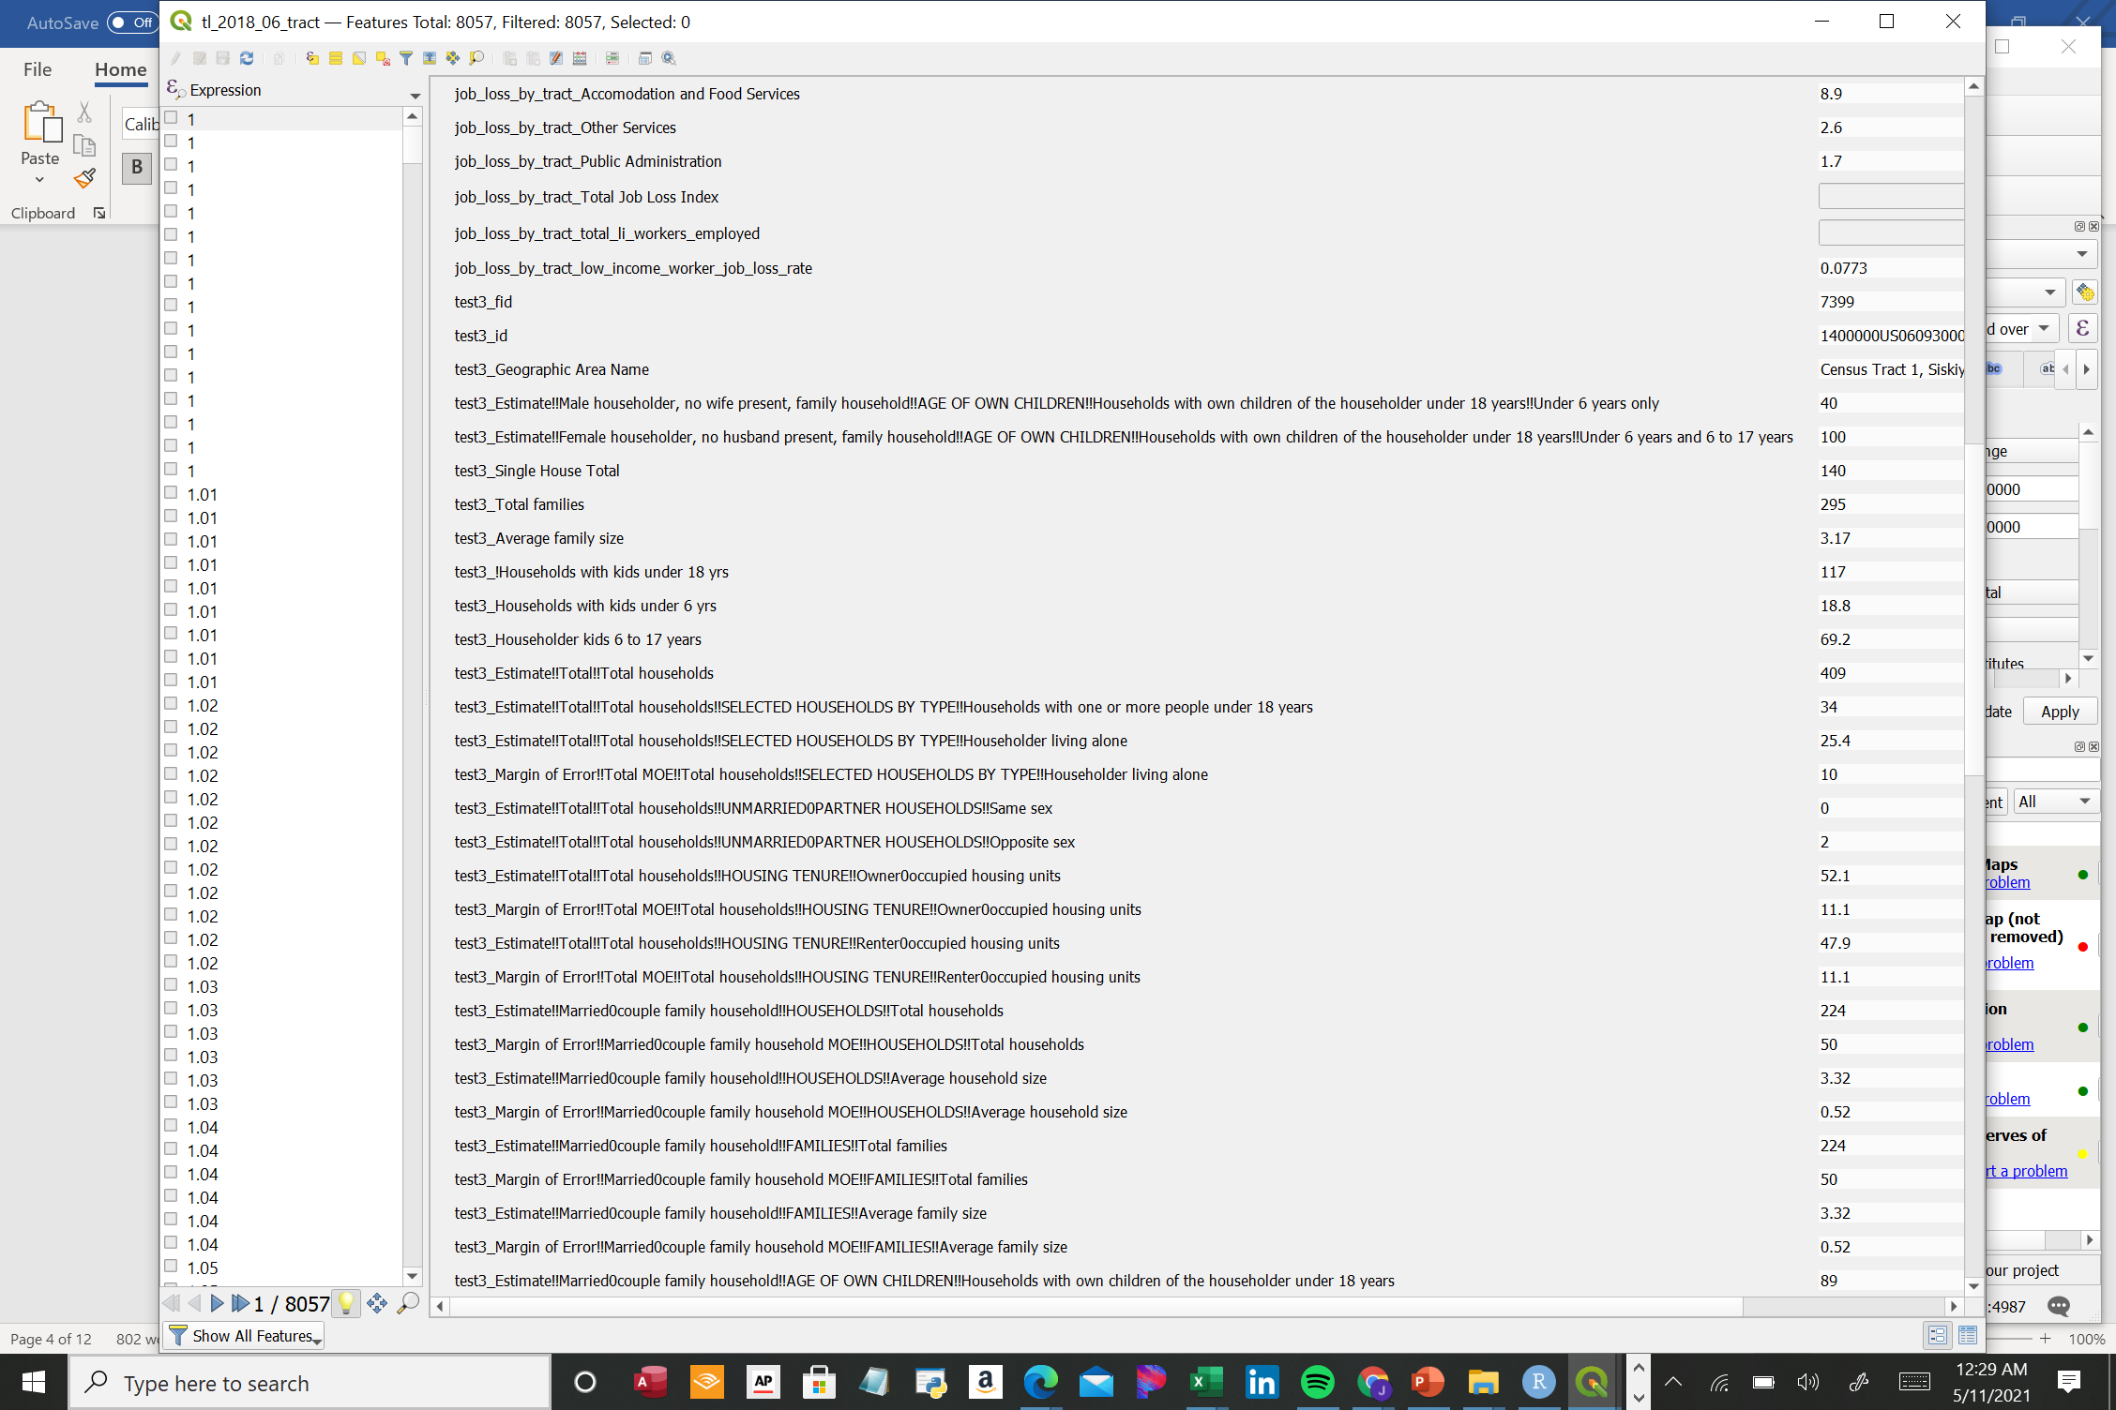

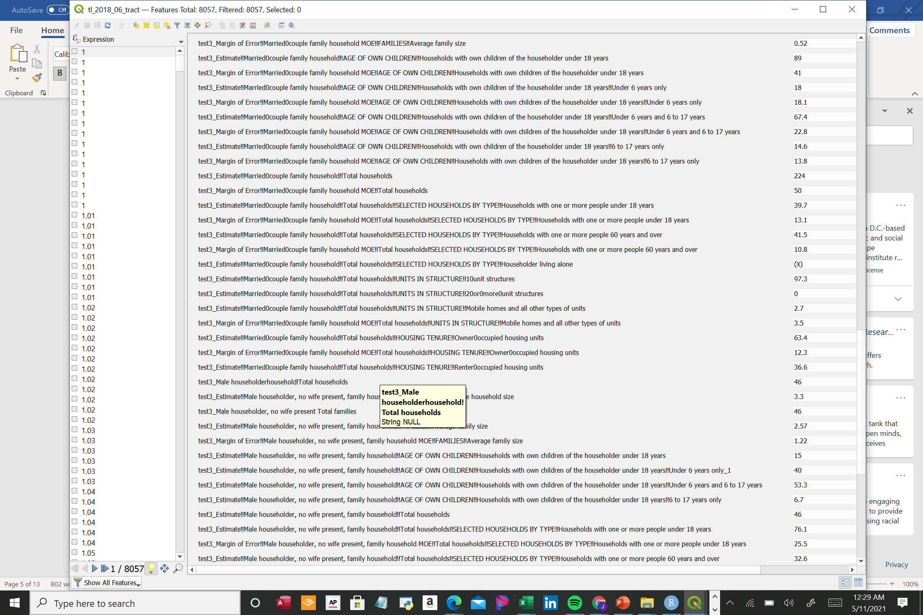

COLOR GRADIENT OF TRACTS BASED ON JOB LOSS PER TRACT

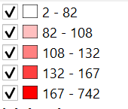

NUMBERS ON THE TRACTS REPRESENT VARIOUS TRACT COUNTS FOR HOUSEHOLD DEMOGRAPHICS

Number of Single Family Home in tract

Number of Families with Children under 18

Number of Singles Alone

Number of Households with Family members over 60 at least one

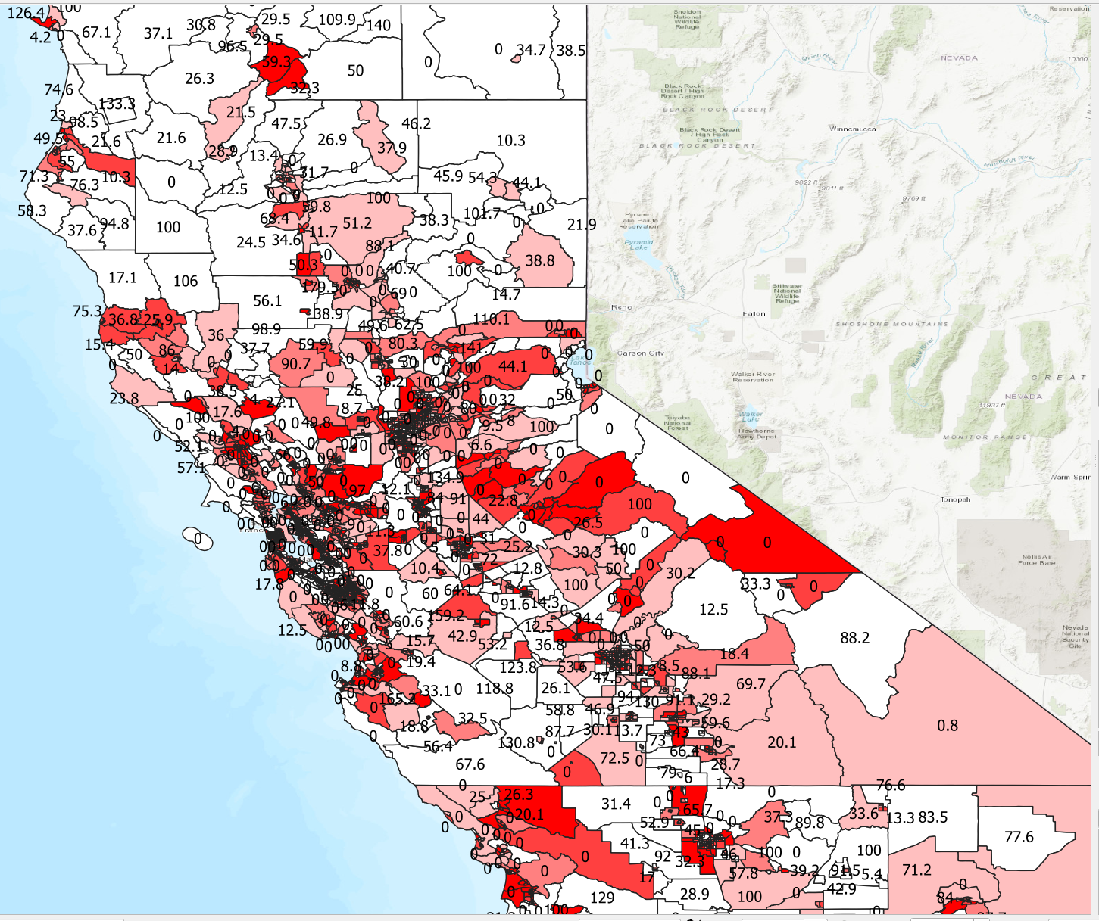

NORTHERN CA VIEW FROM QGIS MAPPING

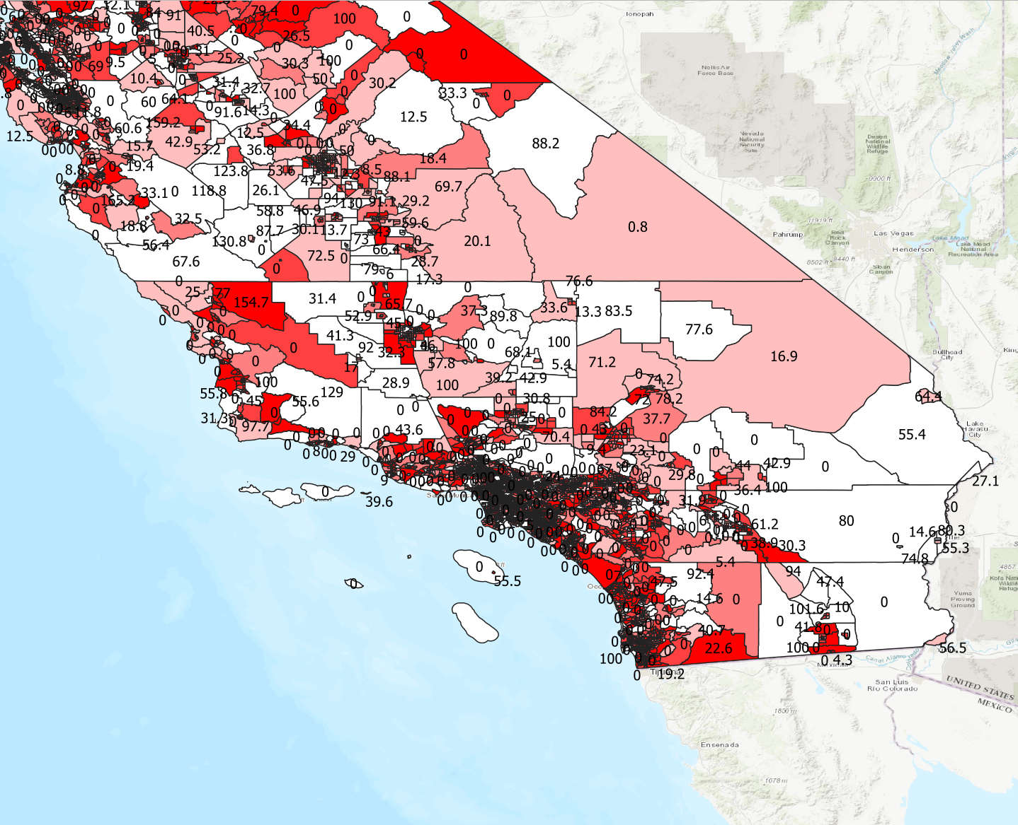

SOUTHERN CA VIEW

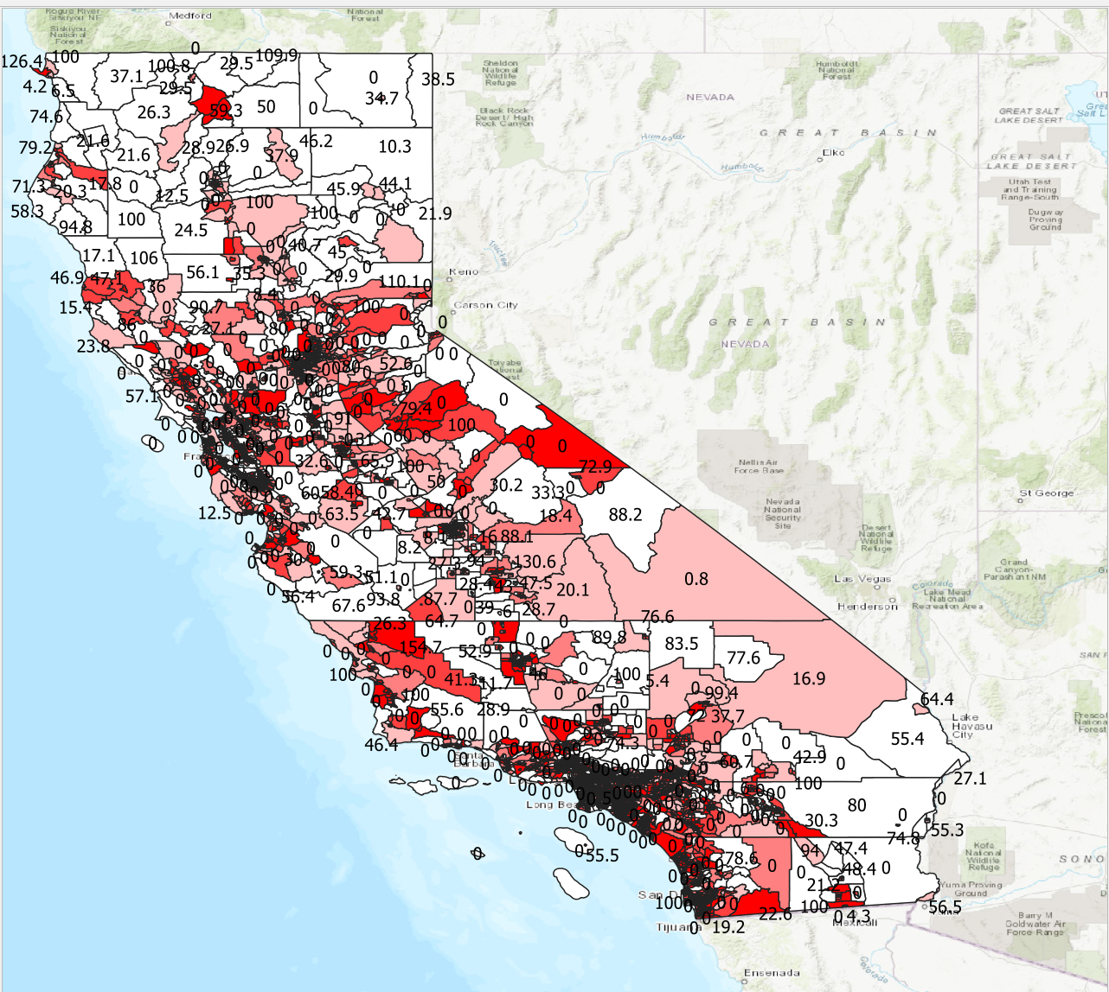

TOTAL NUMBER OF SINGLE HOUSEHOLD HEADED FAMILIES

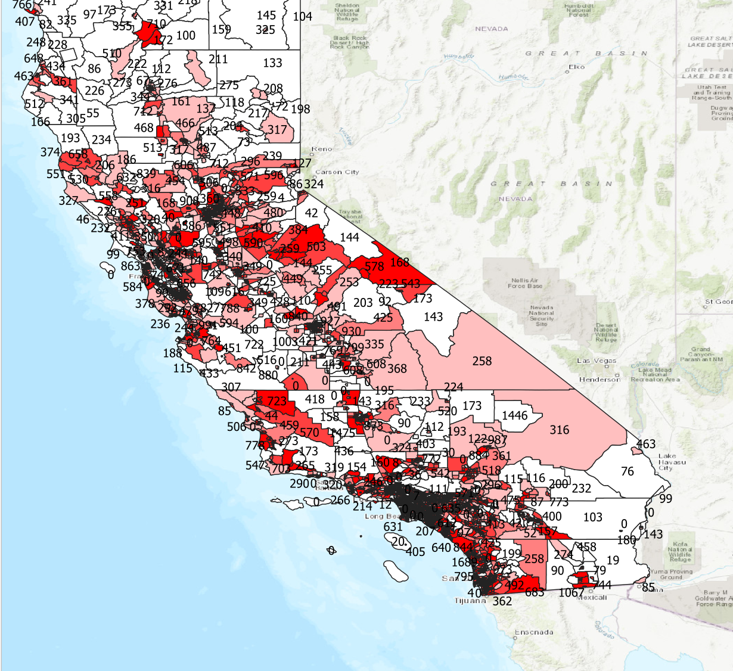

NUMBER OF FAMILIES WITH CHILDREN UNDER 18 IN CALIFORNIA

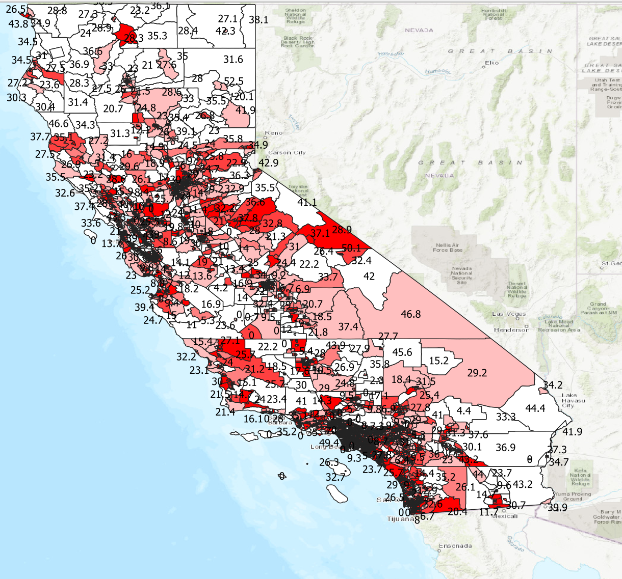

SINGLE PERSON HOMES IN CALIFORNIA

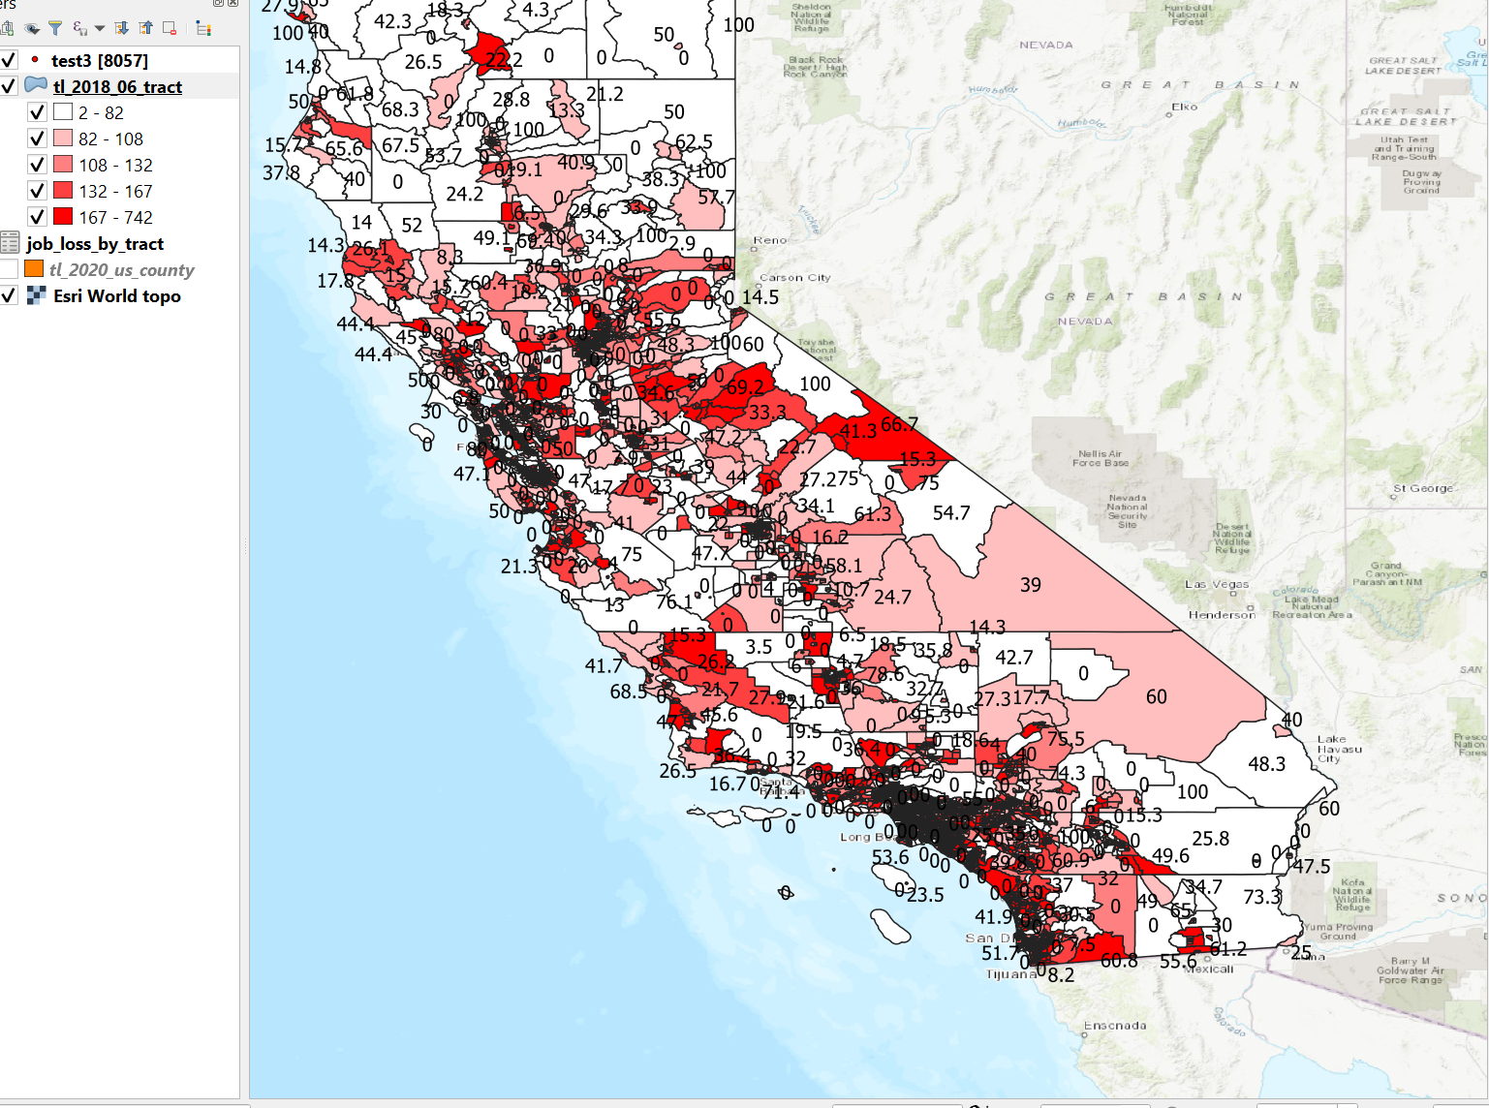

NUMBER OF HOMES WITH ONE OR MORE SENIORS IN CALIFORNIA

Results:

The dataset blended well together, and I feel that you could derive plans of action based on these factors. It would give agency some way of using important to roll out disaster relief on a more need based schedule.

**Conclusions**

Using the factor of job loss by tract clearly identifies tracts that in need of assistance. Including those tracts worse affected by the disaster at hand. The census household data added in shows the demographics in those tracts that need to be assisted more swiftly. These factors of household demographics would probably change depending on the emergency, and who is most at risk. For covid for example I felt that single family type households with children under were at the greatest risk because if they were hit by job loss. They may not have any other source of income for daily expenses and daycare to work. Secondly, families with children under 18 needed relief to help school age kids and preschoolers from home or to make special arrangements for those who work outside the home. The risk factor is equally as great for those who live alone, because if job loss hits there is no source of income but what they qualify for which is possibly unemployment to upkeep their living arrangements. Finally, but not least, the senior group would need assistance to get services to help them live, while they cannot get around to do errands or have no family member near them.

Limitations:

The factors that hindered the analysis is that I was a novice to QGIS, and also the lack of datasets with current census information to make this make the job tract loss data more up to date. There is also the limitation of my knowledge of various analysis tool that possibly could have been utilized to enhance the mapping aspects. There was not tract map of the US to do all the states quickly.

Future Research

The dataset could have easily been mapped for the entire country with a good US shape file. I would really be interested in this process for a country wide map of possible disaster role plans based on a specific state demographics and job loss experience by tract. I think it could empower government for future events of concern to our safety.